1. First of all, all the codes and app environment inside the container is locked and second when you create multiple containers based on that image that locked part is not copied for each container but reused by each container.

Basically, another layer called command layer is added on top of the image to create a container.

1. Now, if you want to inspect your images further,   
   you can use the command 🡺 **docker image inspect <image_id>**



1. You will notice a long output but let’s focus on the main info from this command.
   1. 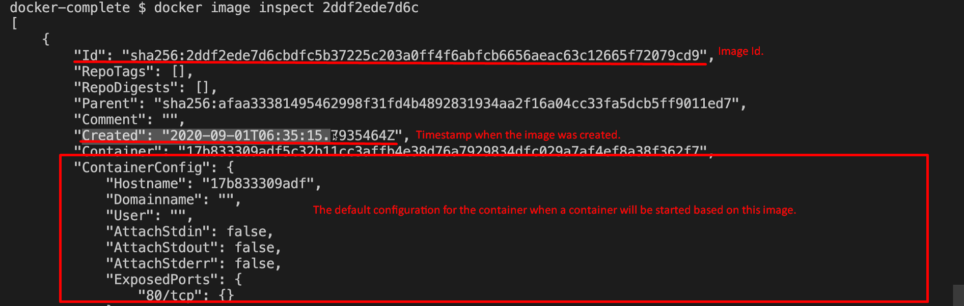
   2. 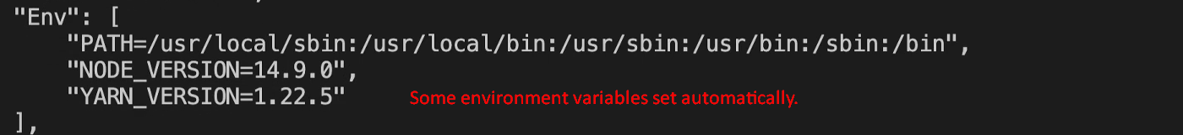
   3. 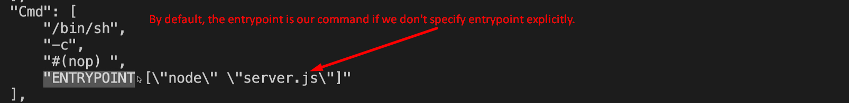
   4. 
   5.   
      Actually, our custom image is based on Node Image which in turn is based on Linux Image.
   6. Text

      Description automatically generated with medium confidence